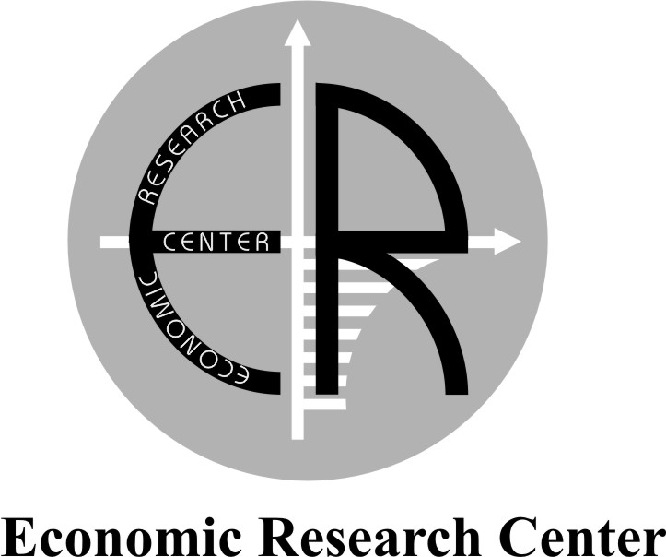

Communications Strategy
for 2011-12

Aim

The aim of this strategy is to get the right and substantial message to the interest and impact groups at the right time.

Target Audiences

Economic Research Center’s audiences are following:

- Internal
Staff

- External
Central government
Local government
Business community
Social community
Scientific and Academic community
International community
Non-governmental organizations (NGOs)
Mass Media
Political parties
Households

Main targets of Communications strategy

- To support in formation of public image
- To support in operating as sustainable research center and to be acknowledged
- To support in development of competitiveness

Key Communication objectives

To help deliver the Center’s targets, vision and values the PR and external communications objectives are following:

- to enlarge scope of already existing relations;
- to build up new partnership links & relationships with various key stakeholders, organizations in the implementation of its activities;
- To enhance relations with Mass Media;
- To strengthen relations and exchange of information with civil society institutes;
- To turn positive tendencies in relations with TVs to sustainable and regular cooperation;
- Investigating cooperation opportunities with state Mass Media to strengthen activity in this direction.

KEY MESSAGES

For successful achievement of our Strategy, we develop four key messages:

  - To political decision-makers: Bringing out objective research product to assist you in formation of sensible policies;

  - To the Business Community: Being your consultant we can reduce your expenses and increase economic effeciency;

  - To the Households: Being your advisor, we can innovate your decision and increase budget’s benefit;

  - To the Social Community: Our researches we help you to understand and assess state policies better.

WHERE WE ARE NOW: A SNAPSHOT OF OUR CURRENT COMMUNICATIONS

Strengths

- Due to Institutional Support Program, the Center managed to develop strong organization capacity;
- The Center has a wide range of established and well-proven external and internal communications;
- The Center has increased cooperation with government, as it began implementing a project on an alternative poverty assessment methodology. The assessment analysis of findings, and policy recommendations will help government design targeted poverty alleviation interventions;
- The Center is recognized as a source of exeprtise and credible information and helps to impact public policy;
- The Center has close relations with state officials;
- The Center is one of the “unfavorable” NGOs in the country that received funding from the State Council on Support to NGOs;
- The Center has developed close cooperation with Business Community (for instance, BP);
- The Center is the only organization in the country (Azerbaijan) having extended international relations (for instance, ENTO, PASOS, Publish What You Pay and etc.);
- The Center is a single organization in the country (Azerbaijan) with well-developed research experience;
- The Center helds leadership role among Alliances, Coalitions of the country (Azerbaijan);
- The Center is highly recognized by the International Community (for instance, Financial Times, CNN Turk, Aljazeera TV and etc.) as alternative and reliable Think Tank;
- The Center managed transparency in internal management;
- The Center maintains high-quality, up-to-date website: www.erc.az;
- The Center is the only NGO in the country that created number of innovative IT tools (tax calculator, inflation calculator and etc.) and offers them to public through its well-established website;
- The Center managed to gather young, active, high-potential staff;
- The Center’s accounting meets international standards already, though it was declared to be done by 2009 by the State;
- The Center has visibly developed media coverage: actively works with mass media, prepares press releases, and organizes press conferences about the launch or completion of its projects.

Weaknesses

- The Center has limited financial resources - due to financial crisis in the world and increase of oil income in Azerbaijan in recent years, some foreign donors stopped or partially continue their program in Azerbaijan (for instance, Oxfam Novib, Conterpart);
- The Center has poor sale market for its research products;
- The Center has fluctuation of staff because of limited financial resources;
- The Center is still not considered as a Think Tank in the country, as there is no legal Think Tank classification of an NGO in Azerbaijan;
- The Center’s budget depends on projects: it doesn’t have own financies, as donors do not meet overhead expenses;
- Lack of professional training organizations on NGO management in Azerbaijan and decrease of number of trainings by donors (for instance, Counterpart International) in recent years;
- The Center doesn’t have Policy Officer, dealing with projects and project writing;
- Corporate governance for NGOs in Azerbaijan is weakly developed: there is no NGO legislation, Advisory Board doesn’t have legal basis;
- Coalitions and Alliances cannot operate as legal entities, as there is no legal basis for it;
- There is no background for organization of economic activity.

Opportunities

- The Center has cooperation opportunity with local NGO Institute;
- The Center has opportunity to work the same Program (Training on Family budget) with other business companies as it did with BP;
- Inclustion of Azerbaijan to Eastern Partnership Program, provides for the Center wide cooperation opportunities with European Institutes;
- The Center can share its good knowledge and skills gained towards accountability, transparency, management with other NGOs in the country;
- Cooperation with CAREC Institute provides for the Center opportunity to access various Institutes, NGOs in Central Asia;
- The Center has opportunity to access well-known Social Networks of the world (for instance, Facebook);
- Increasing of number of members of our networks and membership organizations provides for us more cooperation opportunities;
- Development of the Center’s website.
- The Chairman of the ERC was elected as a member of Strategy Advisory Group on Publish What You Pay International Organization.
- The Chairman of the ERC was elected as a member of Steering Group on Black Sea NGO Forum Region Organization.
- The Chairman of the ERC was elected as the cordinator of Council of NGO Coalition on Improving Transparency in Extractive Industry Organization.

Threats

- Limiting of Freedom of Expression and Association;
- Even more fostering of donors leaving the country (due to the establishment of Oil Fund, the State Fund);
- Decrease of the interest of the business community to research due to negative impact of world financial crisis on them;
- Due to the Center’s critical speeches pressure of the political administration.

Budget

All of the activities related to communications have been funded due to different projects.

Evaluation

All the activities to be monitored on an ongoing basis through:
- Media monitoring and evalutaion;
- Success of initiating and developing partnership working.

